Exp No: 17
UART INTERFACING USING INTERRUPT IN KEIL
AIM:
To receive serial data using interrupt.
APPARATUS REQUIRED:
- PC with Windows OS
- Keil μVision IDE
- 8051 Simulator (Keil built-in)
- Serial Window (UART #1)
PROGRAM:
#include <reg51.h>

void serial_ISR(void) interrupt 4
{
if(RI)
{
P1 = SBUF;
RI = 0;
}
}

void main()
{
TMOD = 0x20;
TH1 = 0xFD;
SCON = 0x50;
TR1 = 1;
ES = 1;
EA = 1;

while(1);
}
OUTPUT:
a) Before Interruption
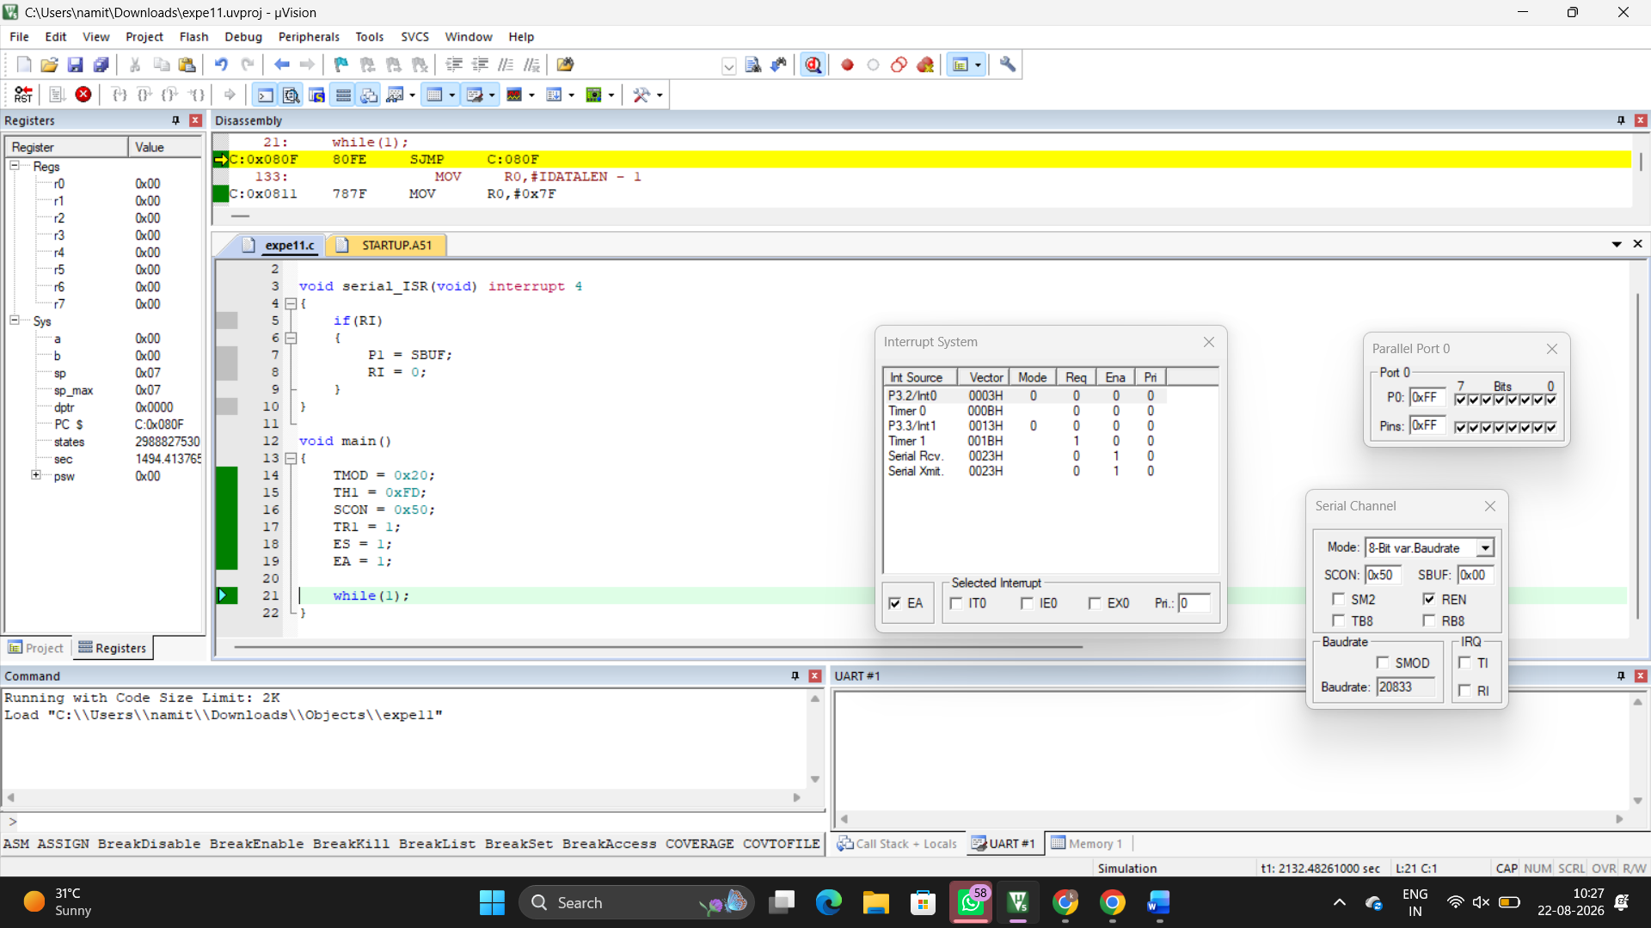

b) After interruption
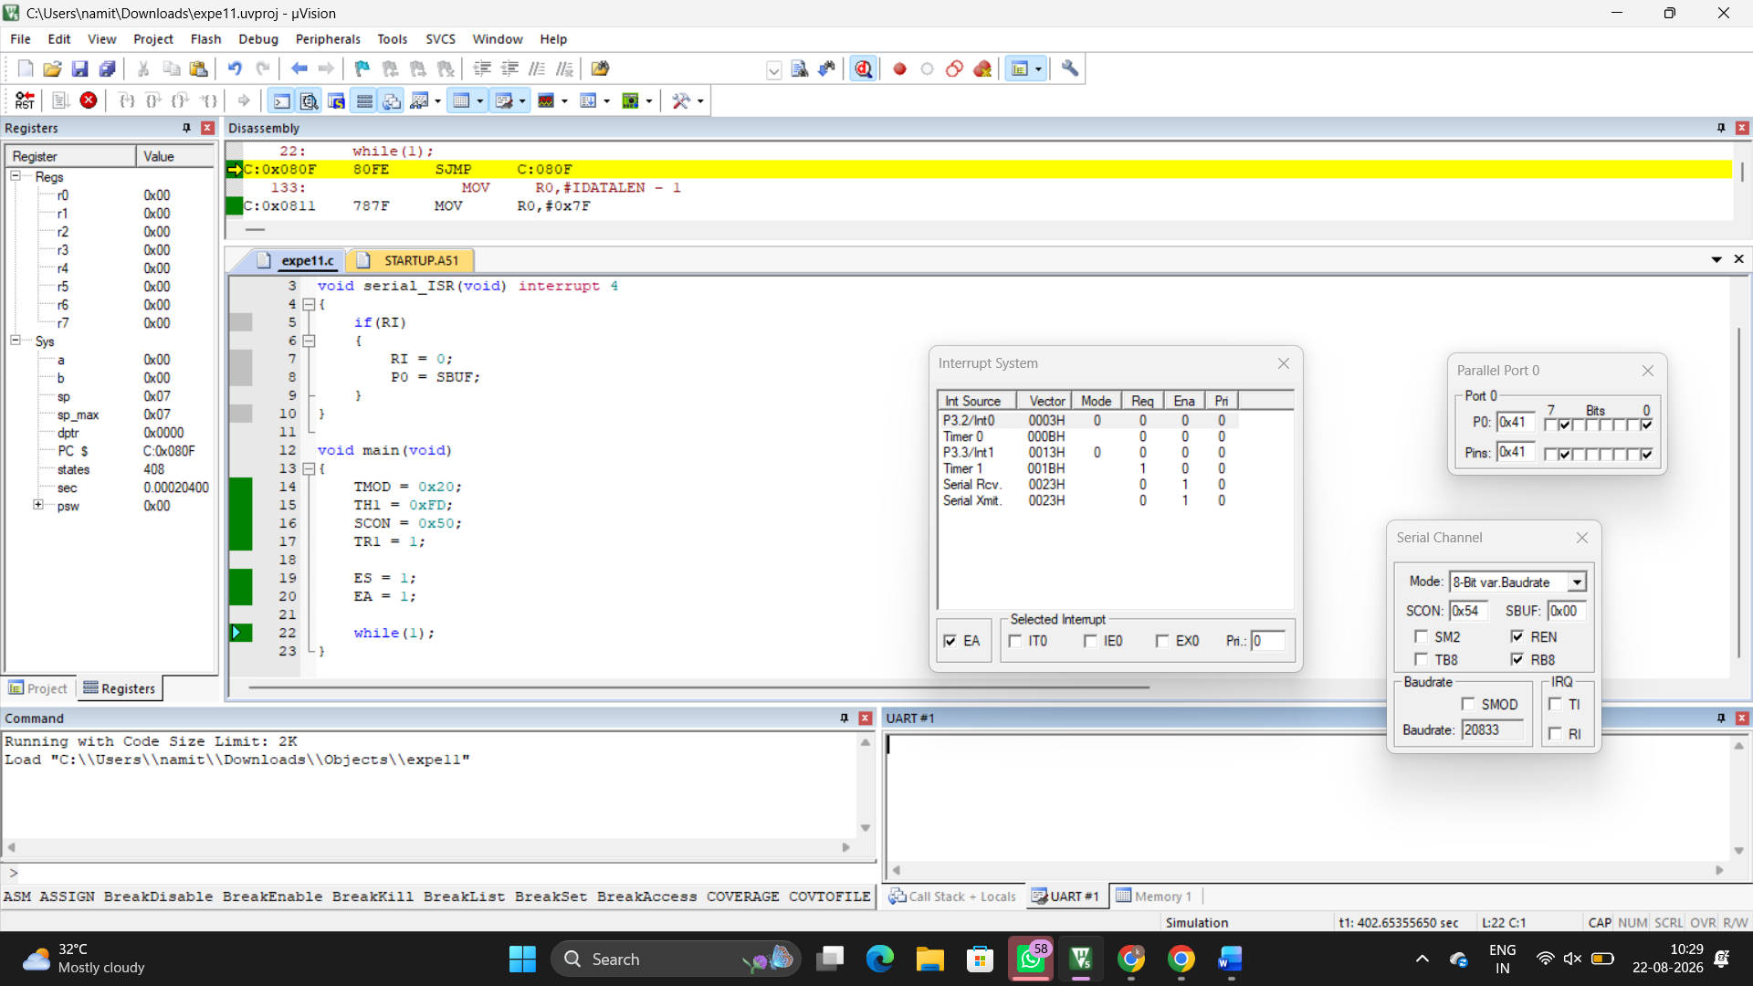
RESULT :
Thus the serial data was received using interrupt and the received data was verified.

